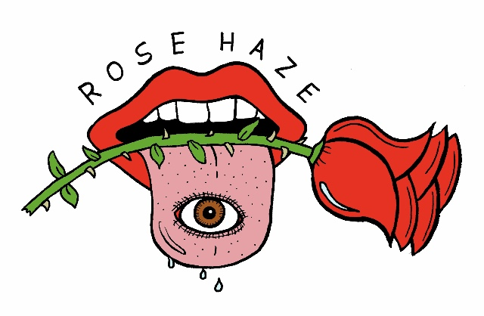

Rose Haze is an ethereal, psychedelic, dreamy and sometimes heavy rock music group led by Kate who also embodies the persona of “Rose Haze” on stage.
Kate was once a rolling stone sharing music from the Midwest to New Orleans, Europe, and Kauai. Now based in Oakland, she has a bay area following and network. Her vast discography tells stories of the lone female traveler experiencing blissful highs and devastating lows while running around from place to place.
She paints unique arrangements of spacey vocals and various instrumentation including acoustic harp, 70s electric pianos, arpeggiators, synths, vintage guitars, and effects pedals onto mood-oriented sonic canvases.
Her personality is as dynamic as her music. Idiosyncratic, honest, and direct, her presence both online and on stage is hers and hers alone. She is supported by an equally energetic band comprised of guitar (Ruben), electric violin (Yoko), bass (Raul or Alejandro), and drums (Dustin)

